**What is JROTC**

The MISSION of the Army junior Reserve Officers’ Training Corps (JROTC) is to “Motivate Young People to be better citizens”

Leadership

* In JROTC, Cadets learn the values of Loyalty, Duty, Respect, Selfless Service, Honor, Integrity, and Personal Courage (LDRSHIP). Also, Cadets will learn the Leadership Traits of Tact, Integrity, Judgment, Decisiveness, Dependability, Enthusiasm, and Endurance. Cadets learn life’s lessons that serve them.
* JROTC opens Cadets up to adventure training, first aide, survival, and marksmanship. Our ultimate objective in JROTC is to develop quality citizenship and leadership to the Cadets by mostly hands on practice than classroom curriculum.
* In JROTC, Cadets learn organization and responsibilities. We also make many friends, having exciting experiences like rappelling, orienteering in the wilderness, and traversing rope bridges.

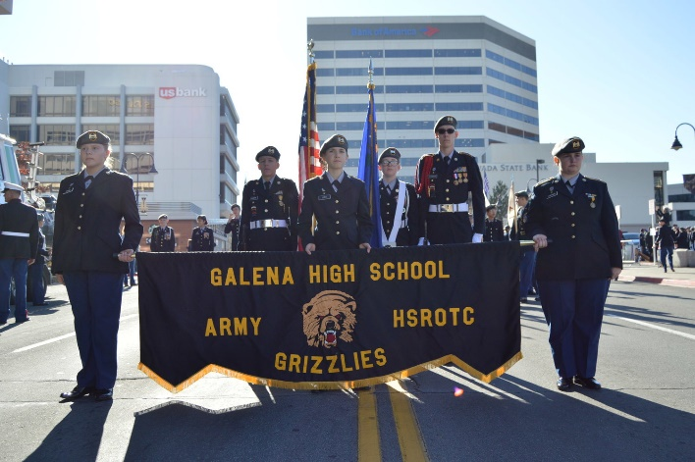

**Solving Problems** together brings us closer as an effective team throughout the community, the school, and the Grizzly Battalion.



What JROTC does:

* Leadership development
* Adventure training that includes Rappelling, Orienteering & Confidence Course.
* Staff planning & principles
* Event planning
* Physical education & Health
* Conflict resolution
* Financial planning & management
* Special teams (Drill and Color Guard)
* Parades
* Flag raising ceremonies

JROTC does **NOT**:

* Recruit for the military; only about 2% of the nation’s JROTC cadets go on to military service.
* Teach combat training or conduct combat operations

JROTC Cadets Learn’

The leadership traits taught in JROTC help us now, in college, and a professional career. These skills will help guide students through and far beyond high school

* **FIRST YEAR CADET**

Understand the Foundations of JROTC; Examine Citizenship; Practice Wellness, Physical Fitness and First Aid; Making Decisions & Goal Setting; Identify and Define Core Values and the Army Values; Demonstrate Employability Skills for Career Readiness; and conduct Service Learning.

* **SECOND YEAR CADET**

Understand the Foundations of JROTC; Explore Leadership Foundations; Examine Citizenship; Practice Wellness, Physical Fitness and First Aid; Apply Personal Growth by Becoming a Better Writer; Understand Basic Leadership; Explore Military Careers; Explore Elements of Communication; and Demonstrate Employability Skills; Conduct Service Learning; Will receive an Honors Credit.

* **THIRD YEAR CADET**

Examine Citizenship; Practice Wellness, Physical Fitness and First Aid; Apply Personal Growth; Understand Basic Leadership; Demonstrate Orienteering; and Demonstrate Employability Skills for Career Readiness; Conduct Service Learning. Will receive an honors credit. At end of third year, Cadets will take Technical and Work Place Assessment Exams; if they pass, and if they have / > 3.0 in Military Science/CTE Course sequence, will graduate with a Career Ready Certificate & Endorsement.

* **FOURTH YEAR CADET**

Explore and Apply Intermediate and Advanced Leadership; Explore Financial Planning; and Explore and Identify Portfolios, Goal Setting, Resume Components, Produce a Job Application; Conduct Service Learning. If a 4th – year Cadet is selected to the Advanced Leadership Course (Sections 5461 & 5462), they will plan and oversee all battalion events, and they will receive an Honors Credit.

**Four semesters completes the PE Requirement, Five semesters the Health Credit, Six and Seven Semesters the CTE / Arts and Humanity Credit. Sophomore and Junior Cadets receive an Honors Credit.**

* JROTC will teach you values and leadership traits that are used in life

**Aubrey Meehan**

**Battalion Commander**

Got questions? Please feel free to contact Lieutenant Colonel Iratcabal at Galena High School [(775) 851-5630](javascript:void(0)), 3600 Butch Cassidy Dr, Reno, NV 89511 , or email at [miratcabal@washoeschools.net](mailto:miratcabal@washoeschools.net)